

Executive summary



January, 01, 2023

[Document title]

[Document subtitle]

Lorem ipsum dolor sit amet, consectetur adipiscing elit, sed do eiusmod tempor incididunt ut labore et dolore magna aliqua. Iaculis urna id volutpat lacus laoreet non curabitur gravida arcu. Dignissim convallis aenean et tortor at risus. Amet consectetur adipiscing elit ut aliquam. Montes nascetur ridiculus mus mauris vitae ultricies. Egestas dui id ornare arcu odio ut sem nulla. Tellus rutrum tellus pellentesque eu tincidunt tortor aliquam. Vitae elementum curabitur vitae nunc. Vitae nunc sed velit dignissim sodales ut. Consequat ac felis donec et odio pellentesque diam.

**Dedication**: Pellentesque pulvinar pellentesque habitant morbi. Eget gravida cum sociis natoque penatibus et magnis dis parturient. Lacus vel facilisis volutpat est velit. Sodales ut eu sem integer vitae justo eget magna. Posuere morbi leo urna molestie at elementum. Pellentesque elit eget gravida cum sociis natoque penatibus. Pulvinar etiam non quam lacus suspendisse faucibus interdum.

**Expertise**: Pellentesque pulvinar pellentesque habitant morbi. Eget gravida cum sociis natoque penatibus et magnis dis parturient. Lacus vel facilisis volutpat est velit. Sodales ut eu sem integer vitae justo eget magna. Posuere morbi leo urna molestie at elementum. Pellentesque elit eget gravida cum sociis natoque penatibus. Pulvinar etiam non quam lacus suspendisse faucibus interdum.

**Partnership**: Pellentesque pulvinar pellentesque habitant morbi. Eget gravida cum sociis natoque penatibus et magnis dis parturient. Lacus vel facilisis volutpat est velit. Sodales ut eu sem integer vitae justo eget magna. Posuere morbi leo urna molestie at elementum. Pellentesque elit eget gravida cum sociis natoque penatibus. Pulvinar etiam non quam lacus suspendisse faucibus interdum.

|  |  |
| --- | --- |
|  | First Last  **Job Title**  [email@nfp.co.uk](mailto:email@nfp.co.uk)  Tel: 012345678910 |

Contents

|  |  |  |
| --- | --- | --- |
| 1 | Your challenges, objectives and aspirations | X |
| 2 | Our response to your questions | X |
| 3 |  | X |
| 4 |  | X |
| 5 |  | X |
| 6 |  | X |
| 7 |  | X |
| 8 |  | X |
| 9 |  | X |
| 10 | About NFP | X |

Appendix

|  |  |  |  |
| --- | --- | --- | --- |
| 1 |  |  | X |
| 2 |  |  | X |
| 3 |  |  | X |
| 4 |  |  | X |
| 5 |  |  | X |

1. Your challenges, objectives and aspirations

Lorem ipsum dolor sit amet, consectetur adipiscing elit, sed do eiusmod tempor incididunt ut labore et dolore magna aliqua. Iaculis urna id volutpat lacus laoreet non curabitur gravida arcu. Dignissim convallis aenean et tortor at risus. Amet consectetur adipiscing elit ut aliquam. Montes nascetur ridiculus mus mauris vitae ultricies. Egestas dui id ornare arcu odio ut sem nulla. Tellus rutrum tellus pellentesque eu tincidunt tortor aliquam. Vitae elementum curabitur vitae nunc. Vitae nunc sed velit dignissim sodales ut. Consequat ac felis donec et odio pellentesque diam.

**Dedication**: Pellentesque pulvinar pellentesque habitant morbi. Eget gravida cum sociis natoque penatibus et magnis dis parturient. Lacus vel facilisis volutpat est velit. Sodales ut eu sem integer vitae justo eget magna. Posuere morbi leo urna molestie at elementum. Pellentesque elit eget gravida cum sociis natoque penatibus. Pulvinar etiam non quam lacus suspendisse faucibus interdum.

**Expertise**: Pellentesque pulvinar pellentesque habitant morbi. Eget gravida cum sociis natoque penatibus et magnis dis parturient. Lacus vel facilisis volutpat est velit. Sodales ut eu sem integer vitae justo eget magna. Posuere morbi leo urna molestie at elementum. Pellentesque elit eget gravida cum sociis natoque penatibus. Pulvinar etiam non quam lacus suspendisse faucibus interdum.

**Partnership**: Pellentesque pulvinar pellentesque habitant morbi. Eget gravida cum sociis natoque penatibus et magnis dis parturient. Lacus vel facilisis volutpat est velit. Sodales ut eu sem integer vitae justo eget magna. Posuere morbi leo urna molestie at elementum. Pellentesque elit eget gravida cum sociis natoque penatibus. Pulvinar etiam non quam lacus suspendisse faucibus interdum.

2. Our response to your question(s)

Lorem ipsum dolor sit amet, consectetur adipiscing elit, sed do eiusmod tempor incididunt ut labore et dolore magna aliqua. Iaculis urna id volutpat lacus laoreet non curabitur gravida arcu. Dignissim convallis aenean et tortor at risus. Amet consectetur adipiscing elit ut aliquam. Montes nascetur ridiculus mus mauris vitae ultricies. Egestas dui id ornare arcu odio ut sem nulla. Tellus rutrum tellus pellentesque eu tincidunt tortor aliquam. Vitae elementum curabitur vitae nunc. Vitae nunc sed velit dignissim sodales ut. Consequat ac felis donec et odio pellentesque diam.

**Dedication**: Pellentesque pulvinar pellentesque habitant morbi. Eget gravida cum sociis natoque penatibus et magnis dis parturient. Lacus vel facilisis volutpat est velit. Sodales ut eu sem integer vitae justo eget magna. Posuere morbi leo urna molestie at elementum. Pellentesque elit eget gravida cum sociis natoque penatibus. Pulvinar etiam non quam lacus suspendisse faucibus interdum.

**Expertise**: Pellentesque pulvinar pellentesque habitant morbi. Eget gravida cum sociis natoque penatibus et magnis dis parturient. Lacus vel facilisis volutpat est velit. Sodales ut eu sem integer vitae justo eget magna. Posuere morbi leo urna molestie at elementum. Pellentesque elit eget gravida cum sociis natoque penatibus. Pulvinar etiam non quam lacus suspendisse faucibus interdum.

**Partnership**: Pellentesque pulvinar pellentesque habitant morbi. Eget gravida cum sociis natoque penatibus et magnis dis parturient. Lacus vel facilisis volutpat est velit. Sodales ut eu sem integer vitae justo eget magna. Posuere morbi leo urna molestie at elementum. Pellentesque elit eget gravida cum sociis natoque penatibus. Pulvinar etiam non quam lacus suspendisse faucibus interdum.

Lorem ipsum dolor sit amet, consectetur adipiscing elit, sed do eiusmod tempor incididunt ut labore et dolore magna aliqua. Iaculis urna id volutpat lacus laoreet non curabitur gravida arcu. Dignissim convallis aenean et tortor at risus. Amet consectetur adipiscing elit ut aliquam. Montes nascetur ridiculus mus mauris vitae ultricies. Egestas dui id ornare arcu odio ut sem nulla. Tellus rutrum tellus pellentesque eu tincidunt tortor aliquam. Vitae elementum curabitur vitae nunc. Vitae nunc sed velit dignissim sodales ut. Consequat ac felis donec et odio pellentesque diam.

**Question**

[Answer] Lorem ipsum dolor sit amet, consectetur adipiscing elit, sed do eiusmod tempor incididunt ut labore et dolore magna aliqua. Iaculis urna id volutpat lacus laoreet non curabitur gravida arcu. Dignissim convallis aenean et tortor at risus. Amet consectetur adipiscing elit ut aliquam. Montes nascetur ridiculus mus mauris vitae ultricies. Egestas dui id ornare arcu odio ut sem nulla. Tellus rutrum tellus pellentesque eu tincidunt tortor aliquam. Vitae elementum curabitur vitae nunc. Vitae nunc sed velit dignissim sodales ut. Consequat ac felis donec et odio pellentesque diam.

**Question**

[Answer] Lorem ipsum dolor sit amet, consectetur adipiscing elit, sed do eiusmod tempor incididunt ut labore et dolore magna aliqua. Iaculis urna id volutpat lacus laoreet non curabitur gravida arcu. Dignissim convallis aenean et tortor at risus. Amet consectetur adipiscing elit ut aliquam. Montes nascetur ridiculus mus mauris vitae ultricies. Egestas dui id ornare arcu odio ut sem nulla. Tellus rutrum tellus pellentesque eu tincidunt tortor aliquam. Vitae elementum curabitur vitae nunc. Vitae nunc sed velit dignissim sodales ut. Consequat ac felis donec et odio pellentesque diam.

**Question**

[Answer] Lorem ipsum dolor sit amet, consectetur adipiscing elit, sed do eiusmod tempor incididunt ut labore et dolore magna aliqua. Iaculis urna id volutpat lacus laoreet non curabitur gravida arcu. Dignissim convallis aenean et tortor at risus. Amet consectetur adipiscing elit ut aliquam. Montes nascetur ridiculus mus mauris vitae ultricies. Egestas dui id ornare arcu odio ut sem nulla. Tellus rutrum tellus pellentesque eu tincidunt tortor aliquam. Vitae elementum curabitur vitae nunc. Vitae nunc sed velit dignissim sodales ut. Consequat ac felis donec et odio pellentesque diam.

**Question**

[Answer] Lorem ipsum dolor sit amet, consectetur adipiscing elit, sed do eiusmod tempor incididunt ut labore et dolore magna aliqua. Iaculis urna id volutpat lacus laoreet non curabitur gravida arcu. Dignissim convallis aenean et tortor at risus. Amet consectetur adipiscing elit ut aliquam. Montes nascetur ridiculus mus mauris vitae ultricies. Egestas dui id ornare arcu odio ut sem nulla. Tellus rutrum tellus pellentesque eu tincidunt tortor aliquam. Vitae elementum curabitur vitae nunc. Vitae nunc sed velit dignissim sodales ut. Consequat ac felis donec et odio pellentesque diam.

**Question**

[Answer] Lorem ipsum dolor sit amet, consectetur adipiscing elit, sed do eiusmod tempor incididunt ut labore et dolore magna aliqua. Iaculis urna id volutpat lacus laoreet non curabitur gravida arcu. Dignissim convallis aenean et tortor at risus. Amet consectetur adipiscing elit ut aliquam. Montes nascetur ridiculus mus mauris vitae ultricies. Egestas dui id ornare arcu odio ut sem nulla. Tellus rutrum tellus pellentesque eu tincidunt tortor aliquam. Vitae elementum curabitur vitae nunc. Vitae nunc sed velit dignissim sodales ut. Consequat ac felis donec et odio pellentesque diam.

**Question**

[Answer] Lorem ipsum dolor sit amet, consectetur adipiscing elit, sed do eiusmod tempor incididunt ut labore et dolore magna aliqua. Iaculis urna id volutpat lacus laoreet non curabitur gravida arcu. Dignissim convallis aenean et tortor at risus. Amet consectetur adipiscing elit ut aliquam. Montes nascetur ridiculus mus mauris vitae ultricies. Egestas dui id ornare arcu odio ut sem nulla. Tellus rutrum tellus pellentesque eu tincidunt tortor aliquam. Vitae elementum curabitur vitae nunc. Vitae nunc sed velit dignissim sodales ut. Consequat ac felis donec et odio pellentesque diam.

**Question**

[Answer] Lorem ipsum dolor sit amet, consectetur adipiscing elit, sed do eiusmod tempor incididunt ut labore et dolore magna aliqua. Iaculis urna id volutpat lacus laoreet non curabitur gravida arcu. Dignissim convallis aenean et tortor at risus. Amet consectetur adipiscing elit ut aliquam. Montes nascetur ridiculus mus mauris vitae ultricies. Egestas dui id ornare arcu odio ut sem nulla. Tellus rutrum tellus pellentesque eu tincidunt tortor aliquam. Vitae elementum curabitur vitae nunc. Vitae nunc sed velit dignissim sodales ut. Consequat ac felis donec et odio pellentesque diam.

**Question**

[Answer] Lorem ipsum dolor sit amet, consectetur adipiscing elit, sed do eiusmod tempor incididunt ut labore et dolore magna aliqua. Iaculis urna id volutpat lacus laoreet non curabitur gravida arcu. Dignissim convallis aenean et tortor at risus. Amet consectetur adipiscing elit ut aliquam. Montes nascetur ridiculus mus mauris vitae ultricies. Egestas dui id ornare arcu odio ut sem nulla. Tellus rutrum tellus pellentesque eu tincidunt tortor aliquam. Vitae elementum curabitur vitae nunc. Vitae nunc sed velit dignissim sodales ut. Consequat ac felis donec et odio pellentesque diam.

3. Timeline and next steps

Lorem ipsum dolor sit amet, consectetur adipiscing elit, sed do eiusmod tempor incididunt ut labore et dolore magna aliqua. Iaculis urna id volutpat lacus laoreet non curabitur gravida arcu. Dignissim convallis aenean et tortor at risus. Amet consectetur adipiscing elit ut aliquam. Montes nascetur ridiculus mus mauris vitae ultricies. Egestas dui id ornare arcu odio ut sem nulla. Tellus rutrum tellus pellentesque eu tincidunt tortor aliquam. Vitae elementum curabitur vitae nunc. Vitae nunc sed velit dignissim sodales ut. Consequat ac felis donec et odio pellentesque diam.

[CREATE NEW DIAGRAM]

4. Conclusion

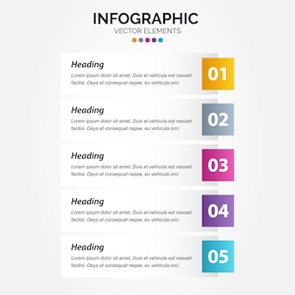

Lorem ipsum dolor sit amet, consectetur adipiscing elit, sed do eiusmod tempor incididunt ut labore et dolore magna aliqua. Iaculis urna id volutpat lacus laoreet non curabitur gravida arcu. Dignissim convallis aenean et tortor at risus. Amet consectetur adipiscing elit ut aliquam. Montes nascetur ridiculus mus mauris vitae ultricies. Egestas dui id ornare arcu odio ut sem nulla. Tellus rutrum tellus pellentesque eu tincidunt tortor aliquam. Vitae elementum curabitur vitae nunc. Vitae nunc sed velit dignissim sodales ut. Consequat ac felis donec et odio pellentesque diam.

5. About NFP

NFP, an Aon company, is an organisation of consultative advisors and problem solvers helping companies and individuals address their most significant risk, workforce, wealth management and retirement challenges. With colleagues across the US, Puerto Rico, Canada, UK and Ireland, we serve a diversity of clients, industries and communities.

Our global capabilities, specialised expertise and customized solutions span commercial business insurance, employee benefits, people consultancy, health and safety, and individual financial planning. Together, we put people first, prioritize partnerships and continuously advance a culture we’re proud of.

Headquartered in the United States, we have been expanding rapidly in the UK and Ireland since 2016, bringing our range of specialist support and solutions to large corporations, SMEs and individuals who need it – no matter which industry they operate in. Through technology, consulting and broking expertise, the specialisms we provide include commercial insurance, employee benefits, HR and health and safety, delivering long-term strategic value for our clients and guiding organisations and their people to thrive. Underpinning everything we do is our people-first philosophy. This not only applies to our employees but is extended to you, our partners and the people that help you grow.

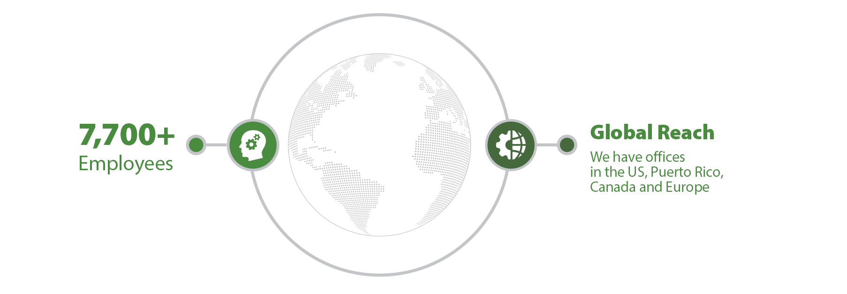

PeopleFirst

We understand that more people means more experience, more expertise, more diversity of thought and more opportunities to understand the world we share. By embracing organic collaboration and innovation, we are able to integrate an array of ideas and perspectives to continuously refine what we do and how we do it.

Building a diverse, collaborative and innovative team requires leadership, deliberate action, and ongoing measurement. We actively support the well-being of our employees with benefits and programs driven by recognition, community, financial well-being tools, development and inclusion, fostering personal and professional growth that keeps us moving forward.

Community and charity

Here at NFP we take pride in supporting the wider community, which is why we actively get involved. This year, we’re continuing our partnership with the Teenage Cancer Trust and Envision. As well as making NFP a great place to work for our colleagues, we want to ensure that we are making a difference in our local communities too. That’s why we challenge all our people to make a commitment to local charities and community initiatives.

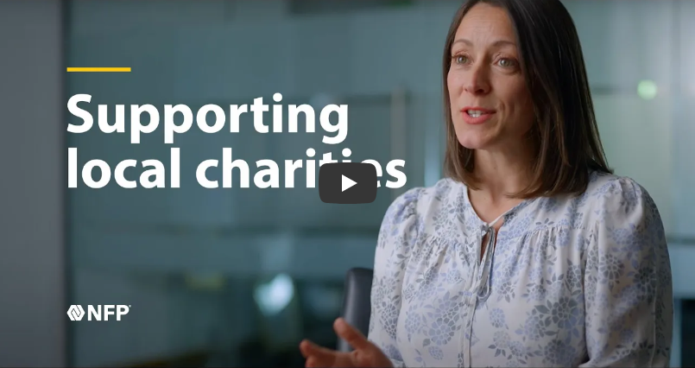

Hear from Gemma how we support local charities >

**Corporate social responsibility**

Our corporate social responsibility (CSR) commitments refer to our responsibility toward society. Our company doesn’t exist in isolation; it’s part of a bigger system of people, values, other organisations and nature. Businesses have a responsibility to ensure they are having a positive impact on the world. This is something that’s at the heart of everything we do.

|  |  |  |
| --- | --- | --- |
| [RECREATE THIS IMAGE] | [RECREATE THIS IMAGE] | [RECREATE THIS IMAGE] |
| Defining clear and measurable key performance indicators and goals to monitor performance. | Focusing on using effective communications to create excitement, foster a culture of sustainability, and educate all NFP team members on how sustainability impacts them, our company and other NFP stakeholders. | We strive to have a positive impact on our surroundings by investing money, as well as our time, passion and effort, to support initiatives, campaigns and charities that help improve local communities and the lives of those who live within them. |

**Integrating diversity, equity, inclusion and belonging into everything we do**

Fostering a culture of belonging with employees, clients and communities starts with strategy, and continues with learning, acting, refining and moving forward with a belief that we are never done.

NFP embraces the unique identities of our employees and welcomes cultures of diversity, equity, inclusion and belonging, informing every aspect of our business and empowering our people to succeed.

Diversity, equity, inclusion and belonging are essential to everything we do. Ensuring our people bring their best selves to work every day by placing as much importance on family and community as they do their valuable work, helps them to better support clients’ needs. Simply put, it’s good for our people and it’s good for business.

**Our DEIB policy statement**

NFP seeks to cultivate an enterprise-wide DEIB strategy that is aligned with business objectives and creates systems and cultures of diversity, equity, inclusion and belonging, permeates every aspect of the business, and empowers all employees and stakeholders, both internally and externally, to succeed.

NFP is committed to DEIB because we know that a company is only as great as its employees. We continually seek out professionals with diverse characteristics and unique life experiences, knowledge, self-expression, capabilities and talent. Together we form a community that celebrates individual differences, shares perspectives and emphasizes belonging so people can be their authentic selves. Our community acknowledges contributions from everyone, no matter their education, opinions, culture, ethnicity, race, sex, gender identity and expression, nation of origin, age, generation, languages spoken, veteran’s status, colour, religion, disability, sexual orientation and beliefs.

Our CEO and senior executives are committed to these initiatives, setting the tone for the entire organization. The NFP DEIB Advisory Board, composed of employees at all levels of the organization, spearheads initiatives that encourage a better, more inclusive work environment; promote opportunities for NFP to achieve workplace diversity, inclusivity and cultural competency; and align DEIB strategies with organizational goals and objectives to enhance the business of NFP. Likewise, our Business Resource Groups for Women, Black Professionals, LGBTQ+, Military & Veterans, Asian, Latine, Disabled and Families form a collaborative, supportive community where both members and their allies join with the community at large to advance the members’ development and NFP as a business.

We drive our vision internally and externally through four pillars: Employee, Client, Community and Supplier.

**Employee:** This group is focused on diversifying our workforce through internal processes and opportunities that will support attraction and retention and grow talent, innovation and a sense of belonging for all.

**Community:** This group is focused on diversifying our charitable activities and involvement with programs that reflect historically underrepresented populations and align with NFP's goals and values.

**Client:** This group will focus on enriching NFP's client relationships by illustrating our D&I practices, as well as develop offerings relevant to all organisations that have D&I priorities.

**Supplier:** This group is focused on tying into and strengthening inclusive vendor relationships. We'll examine internal processes and determine how to better diversify and enhance vendor partnerships.

As part of this work, we collaborate and partner with other like-valued organizations to effectuate change and positively impact our communities: supporting initiatives and organizations dedicated to building a more diverse, equitable, inclusive community and industry. In addition, NFP has created a Supplier Diversity Program (SDP) to develop, promote, improve, and increase diverse supplier partnerships and spend within the corporate supply chain. The SDP serves to prioritize our DEIB philosophy in the broader market by proactively establishing and strengthening relationships with diverse suppliers. By maximizing procurement opportunities, NFP can actively commit to achieving equal business opportunities and leverage business expansion in underrepresented communities and markets.

The more diverse and inclusive we are, the better we can serve our clients, the more effectively we can innovate and grow our business, the more we can positively impact our communities around the world, and the more successfully we can establish a legacy to be proud of. NFP is committed to respecting every person, and this expectation extends externally to our clients, communities and suppliers.

**DEIB Advisory Board**

NFP’s DEIB Advisory Board is the driving force behind our company’s efforts to advance diversity, equity, inclusion and belonging (DEIB).

Advisory board members collaborate to advise and recommend DEIB policies, procedures and action plans; help NFP integrate DEIB strategies, initiatives and best practices that align with and advance NFP’s business objectives; drive DEIB communications and serve as ambassadors across the organisation and externally.

Our DEIB Advisory Board includes employees from across the organisation in various positions, specialties and levels of leadership. They are key members that engage with employees, provide support and drive initiatives within the company.

**Our differences are what define and align us**

Combining unique perspectives and celebrating diversity makes us better for our people and our clients.

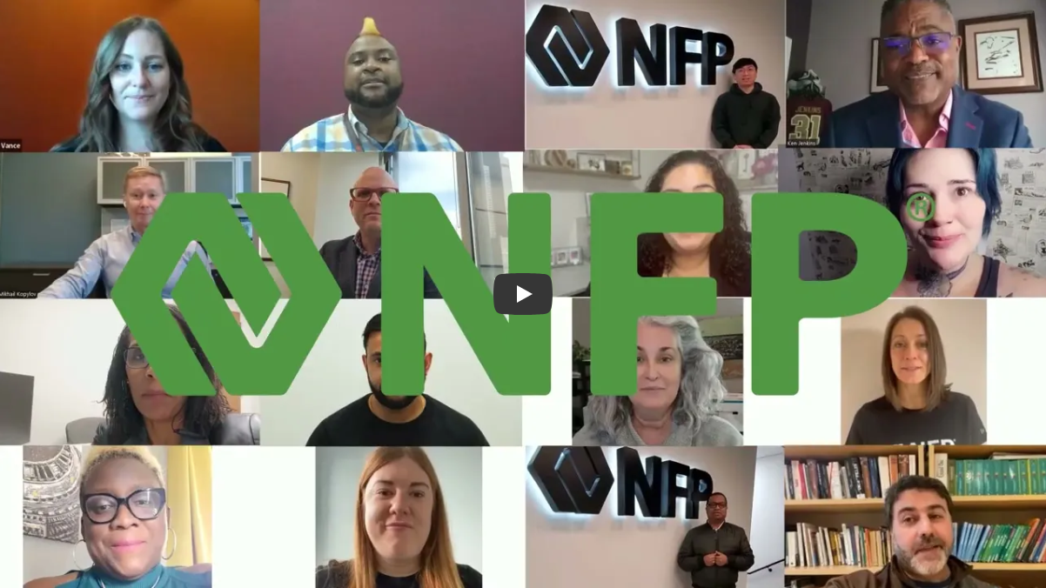

Watch our DEIB video >

Preserving the environment

Preserving the environment means so much to us at NFP, and it’s an area we continue to grow in. We will:

* Look to reduce, reuse and recycle where we can
* Be mindful of how our business impacts the environment and our local communities
* Not promote initiatives which have a detrimental impact to environmental causes
* Continually review the way we operate to include changes that consider sustainability by design
* Take into account the environmental and social governance procedures of the partners we work with
* Promote our green initiatives

6. NFP’s specialties

[Grab your reader’s attention with a great quote from the document or use this space to emphasize a key point. To place this text box anywhere on the page, just drag it.]



We offer a complete package of complimentary services for your business, tailored to your industry, and designed to support and protect your most valuable assets - your property, your people and your customers. Our network of business partners can help you ensure you are legally compliant, covered for the unexpected, competitive in the battle for talent, and supported to develop your managers and teams, to help your business grow.

|  |  |
| --- | --- |
| Commercial insurance  Protecting your business from potential threats is an important part of your success. That’s why it’s so important to work with a partner like NFP to assess your entire operation to find those hidden risks that could derail your achievements.  **Helping your business ensure:**   * your insurance programme is suitable for you * there are no gaps in your cover * you get the support you need to get you back up and running, should a claim occur | Health and safety  We’ll help you keep your workplace, your people, and your equipment safe, offering a tailored service designed to meet your individual needs, from one-off audits, inspections and risk assessments, to providing all of your health  and safety documentation, training and ongoing support services.  **Supporting your business with:**   * audits and inspections * production of policies and management systems * health and safety training |
| Employee benefits  Our employee benefits team provide an end-to-end service, from crafting and evolving your  strategy, to using our brokerage skills and provider relationships to find the best solutions for your needs, right through to the day-to-day management of benefits.  **Helping your business:**   * ensure your benefits strategy is   competitive in your sector   * remove the time and risks associated with managing your employee   benefits and workplace pension   * improve engagement with your employee benefits | HR and people solutions  Whether you’re undergoing organisational change that will impact your people, or you need to introduce fit-for-purpose policies and structures that support modern day working practices, or you want to support the professional development of your leaders and teams - we’re here to help.  **Packaged and bespoke solutions designed to help your business:**   * manage organisational change and restructuring * improve the performance of your people * strengthen your leadership team |

7. Your NFP support team

|  |  |
| --- | --- |
|  | First Last  **Job title**  Lorem ipsum dolor sit amet, consectetur adipiscing elit, sed do eiusmod tempor incididunt ut labore et dolore magna aliqua. Iaculis urna id volutpat lacus laoreet non curabitur gravida arcu. Dignissim convallis aenean et tortor at risus. Amet consectetur adipiscing elit ut aliquam. Montes nascetur ridiculus mus mauris vitae ultricies. Egestas dui id ornare arcu odio ut sem nulla. |
|  | First Last  **Job title**  Lorem ipsum dolor sit amet, consectetur adipiscing elit, sed do eiusmod tempor incididunt ut labore et dolore magna aliqua. Iaculis urna id volutpat lacus laoreet non curabitur gravida arcu. Dignissim convallis aenean et tortor at risus. Amet consectetur adipiscing elit ut aliquam. Montes nascetur ridiculus mus mauris vitae ultricies. Egestas dui id ornare arcu odio ut sem nulla. |
|  | First Last  **Job title**  Lorem ipsum dolor sit amet, consectetur adipiscing elit, sed do eiusmod tempor incididunt ut labore et dolore magna aliqua. Iaculis urna id volutpat lacus laoreet non curabitur gravida arcu. Dignissim convallis aenean et tortor at risus. Amet consectetur adipiscing elit ut aliquam. Montes nascetur ridiculus mus mauris vitae ultricies. Egestas dui id ornare arcu odio ut sem nulla. |
|  | First Last  **Job title**  Lorem ipsum dolor sit amet, consectetur adipiscing elit, sed do eiusmod tempor incididunt ut labore et dolore magna aliqua. Iaculis urna id volutpat lacus laoreet non curabitur gravida arcu. Dignissim convallis aenean et tortor at risus. Amet consectetur adipiscing elit ut aliquam. Montes nascetur ridiculus mus mauris vitae ultricies. Egestas dui id ornare arcu odio ut sem nulla. |
|  | First Last  **Job title**  Lorem ipsum dolor sit amet, consectetur adipiscing elit, sed do eiusmod tempor incididunt ut labore et dolore magna aliqua. Iaculis urna id volutpat lacus laoreet non curabitur gravida arcu. Dignissim convallis aenean et tortor at risus. Amet consectetur adipiscing elit ut aliquam. Montes nascetur ridiculus mus mauris vitae ultricies. Egestas dui id ornare arcu odio ut sem nulla. |
|  | First Last  **Job title**  Lorem ipsum dolor sit amet, consectetur adipiscing elit, sed do eiusmod tempor incididunt ut labore et dolore magna aliqua. Iaculis urna id volutpat lacus laoreet non curabitur gravida arcu. Dignissim convallis aenean et tortor at risus. Amet consectetur adipiscing elit ut aliquam. Montes nascetur ridiculus mus mauris vitae ultricies. Egestas dui id ornare arcu odio ut sem nulla. |

7. Your NFP support team